Group Members: Zimzy B, JD E, Yasbeth P

Project Outline: Bobcat Claws is a Texas State University local store price comparer. We plan to expand on the existing website to allow users to compare products based on price (given price and full price+tax included) and other product details such as quantity, brand, price per ounce, availability, markup price, and store location.

Bobcat Claws should provide accurate, up-to-date information on products that users search for. No log-in should be required for app usage, but should be available to users for additional features. Additionally, Bobcat Claws should not accept sponsors or advertisements.

Spec Doc:
- Define Goal

Expand a legacy system to support a greater set of data. Allow Bobcat Claws to present product data from vendors outside of university association. This information should be relevant to a location specified by the user.

Requirements
1.0 User
1.1 Functional
1.1.1 Users should be able to look up and select the specific store location they are looking for.
1.1.2 Users should be able to see a list of products held at the location.
1.1.3 Users should be able to sort products by various field types (price, brand, category).
1.1.4 Users should be able to see the price per ounce for a product based on brand.
1.1.5 Users should be able to filter out stores they do not prefer.
1.1.6 Users should be able to have the option to log in or sign in as a guest.

2.0 System
2.1 Functional
2.1.1 The app should have an accurate and functioning search feature.
2.1.2 The app should have multiple functioning tabs for users to access.
2.1.3 The app should have an option to create an account, log in, or sign in as a guest.
2.1.4 The app should be able to scrape store websites for data relevant to the user’s request.
2.1.5 The app should return data that is within a reasonable distance of the user’s location
2.1.6 The app should be able to store and access data the user has provided to utilize personalization features (store/distance filtering, etc.)

2.2 Non-Functional
2.2.1 The search bar should be visible and easy to access.
2.2.2 The system will have an up-to-date database of brand and product data.
2.2.3 The database should store accurate tables of all products available to customers.
2.2.4 There should be tabs displayed in the app that take users to other correct pages
2.2.5 The app should display a landing page that immediately shows users a page asking if they either want to log in, create an account, or sign in as a guest
2.2.6 The app should only prioritize the lowest cost of an item and not give priority to advertisers.

- Break It Down

  - By Task

- The database server needs to be up and running for the website to function.
- The legacy system needs to be updated to work with modern architecture and dependency updates.
- The legacy system code must be updated to match proper dependency syntax.
- The website should support vendors outside of university association, in products and branding.
- The website should have the option whether to have their data saved for personalization or not.
- The website needs to return data from stores that are relevant to the location of the user
- The website needs to have the capability to filter stores based on user preference.
- The website layout needs to appear as intuitive and not intimidating or cluttered

  - By Responsibility

Zimzy: Database Server Revival and maintenance, dependency review and updates, project architecture refactoring, system review and testing, user data security planning/implementation/testing, additional feature testing, website deployment and testing, final project deliverable

JD: Site scraping, location functionality, Location store scan implementation, Database product extension

Yasbeth: Dependency refactoring, syntax review/updates, login implementation/design, and implementing search functionality

What is the deliverable?

A storefront website that accurately compares prices of products from vendors in San Marcos including big-name stores like Walmart and HEB, and provides links for customers to purchase products directly from the vendor.

- Server functionality
- Website scraping functionality
- Location identification
  - Guest account by default to prevent user data requests.
  - Option to create account for access to personalization features (filtering etc.)
- Store filter personalization
- User data consent/storage
- Website/App UI
- Website search bar
  - Item search
  - Potential coupon integration

Architecture Mockups:

Architecture:
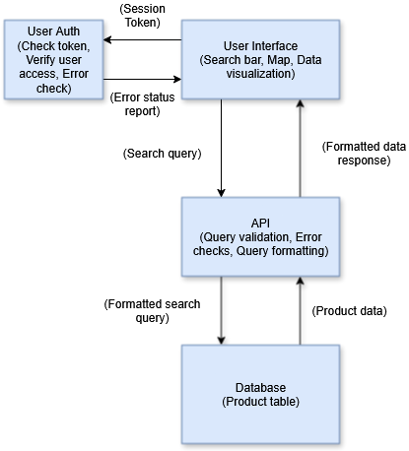

User Dashboard General Mockup:
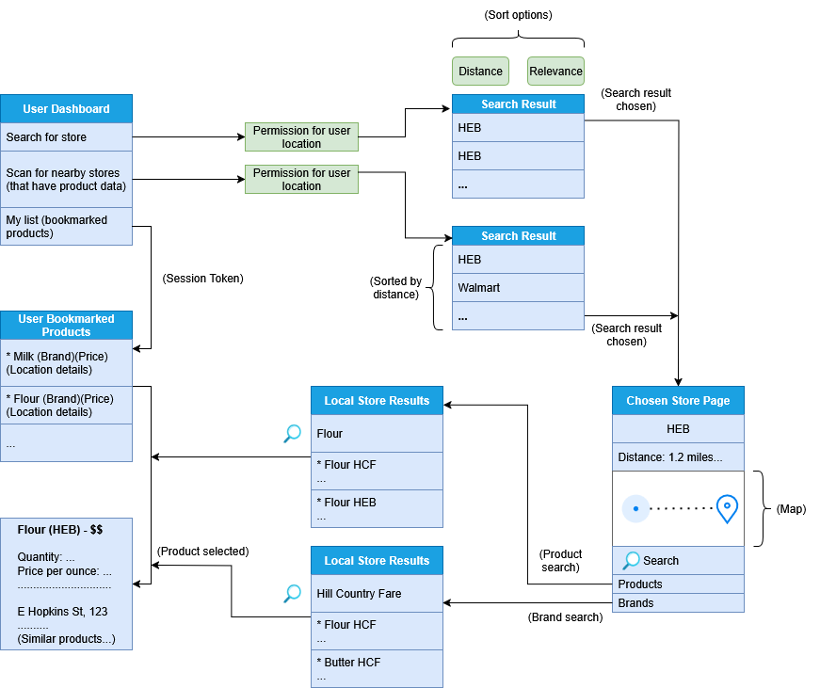

Proposal Tweaks:

Scope too big, reduce location and vendor scope. Hardware needed. Focus on sales over coupons. Half of time on testing. Security issues may have templates (log-in templates, password security templates).

Project Manager: Zimzy
Documentation: JD E (with full team overlap)

May switch focus on food
MAKE PROPOSAL LOOK WOW! (and professional).

Central hosted server is important for authentication
SSL certificate

AWS server

